III Terraform Assignment: Provisioning VPC, RDS, and Lambda with Terraform

**Assignment Title:** Provision a VPC, RDS, and Lambda with Terraform  
 **Level:** Intermediate / Internship  
 **Course:** DevOps / Cloud Engineering

**Task 1: Install and Set Up Terraform**

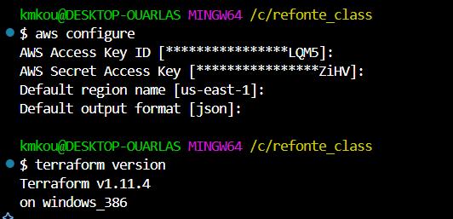

Terraform is an infrastructure as a code that help provision infrastructure on clouds environment and on-premise resources as well. It is cloud agnostic meaning that it can be used to provision resources on any cloud environment. Its benefit also is that it can be versioned, can be reused and easy to share and to edit the code if needed.

To integrate it on AWS, you should install terraform as well as aws-cli, create a user on AWS with access and secret key and run aws configure command on your git bash to authenticate to AWS.

**Task 2: Create a VPC, Subnets, and Security Group**

Terraform apply

**Task 3: Provision an RDS Instance**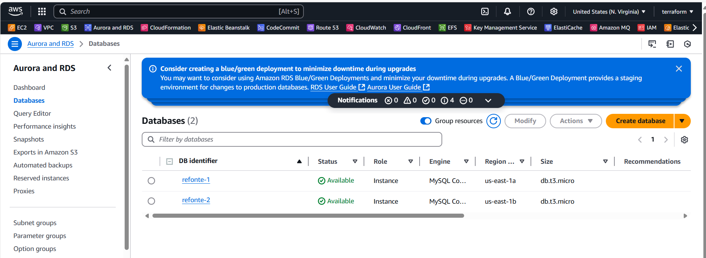

**Task 4  Provision a Lambda Function**

**Do not have experience with Lambda function. I am doing this using ChatGPT & documentation**

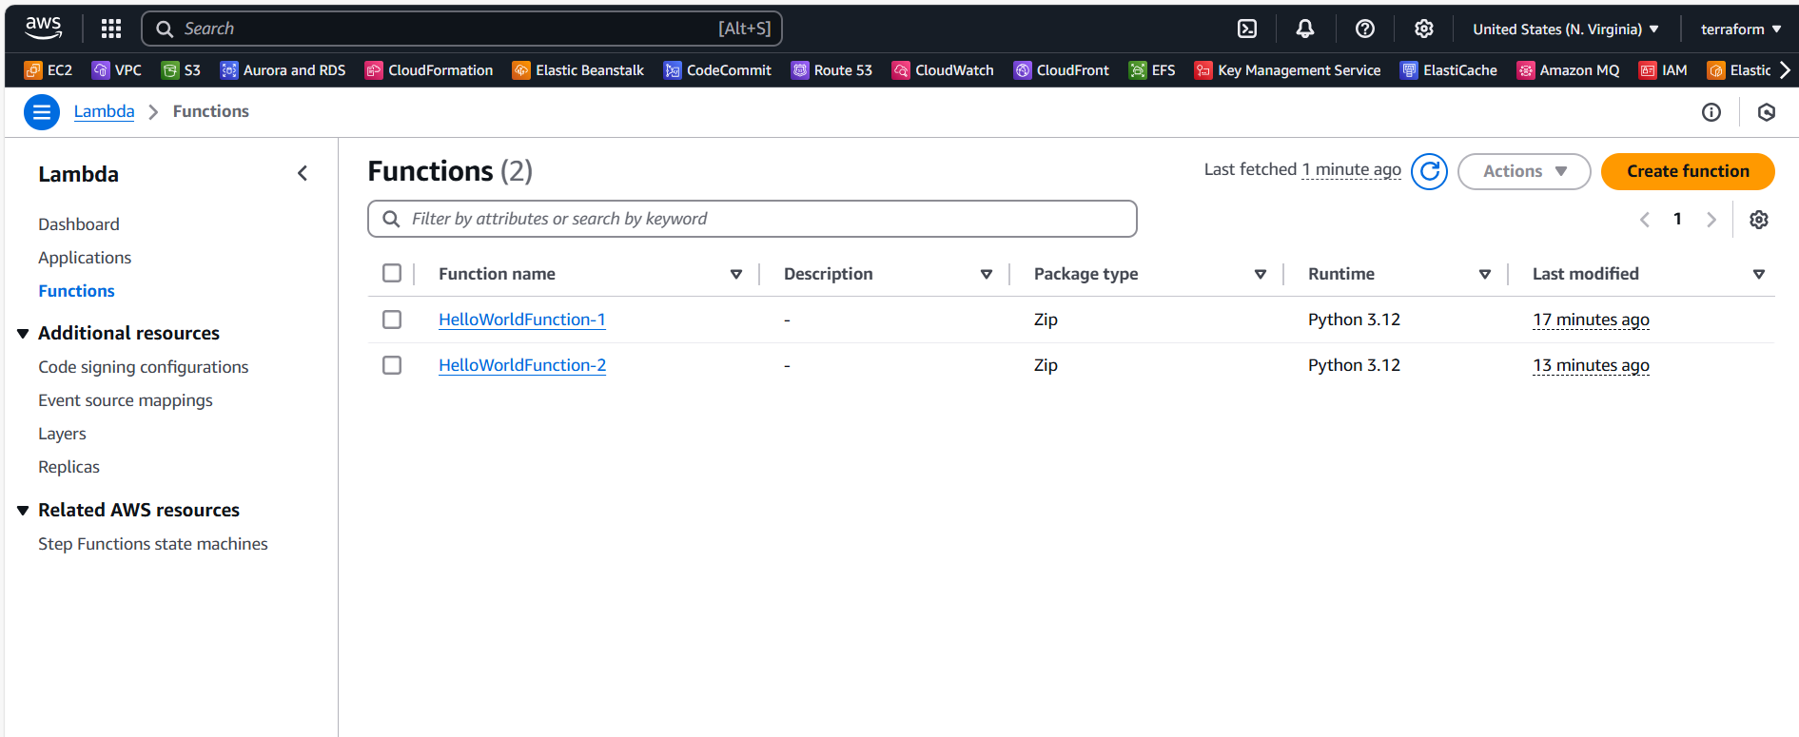

**Task 5: Use Variables and Outputs**

I created a CloudWatch log stream but can’t find it in the CloudWatch UI

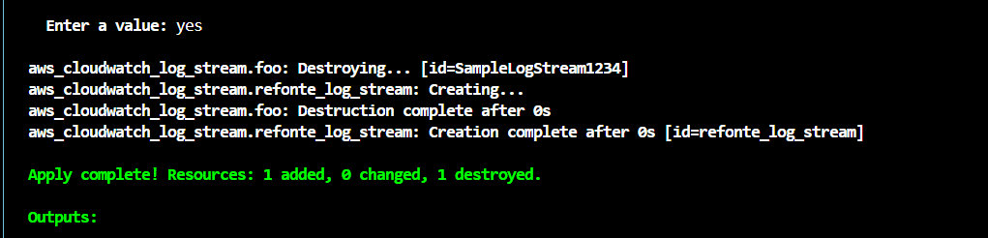

Was able to find it now. I edited the code And added an alarm for CPU utilization

* **Set up RDS automated backups** and monitoring.

Replace Mysql with PostgreSQL



